Chloe Angharad Morgan
Students with Disabilities Officer
2017-2018
Swansea university accessibility report 2018
Singleton Park Campus and Bay Campus
Contents

2. Introduction
3. Section A – Singleton Park Campus
23. Section B – Bay Campus
31. Conclusion

Introduction

This report aimed at assessing the accessibility of Swansea University Singleton Park Campus and Bay Campus. This was done to allow identification of areas of the university which need changing to ensure it is fully inclusive.

It is vital to ensure that the university is fully inclusive, as if there are areas which are not fully accessible, the university may be seen as discriminating against students with disabilities. It is important that all students are given an equal opportunity in the university and their education should not be compromised as a result of problems in the university.

Given the age of the university and the age of some of the buildings within it, there are some things which may be inaccessible. This is understandable and in some cases unavoidable due to building structure or grade listing of buildings. This report does not aim to draw on problems which cannot be rectified but instead focuses on issues which can easily be changed.

This report aims to be as comprehensive as possible but it is possible that some issues may have been missed and therefore there may be additional problems which need to be addressed. The information in this report is also as up to date as possible. The data was collected on the 19th and 21st of April 2018.

The Carmarthen Campus was not included in this report as a result of logistical problems but it is hoped that this report will allow for an investigation of the St David’s Park Campus.

It is hoped that this report will lead to changes being made in the university as it is clear that changes do need to be made in order to make the university inclusive.

Section A – Singleton Park Campus
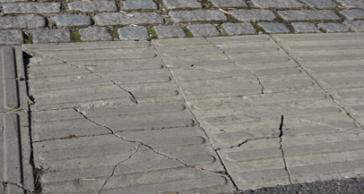
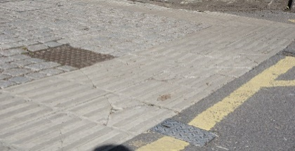
- Finance Building. Outside of the finance building, there are a number of broken paving stones which create a hazard for the visually impaired, wheelchair users and anyone with mobility issues.

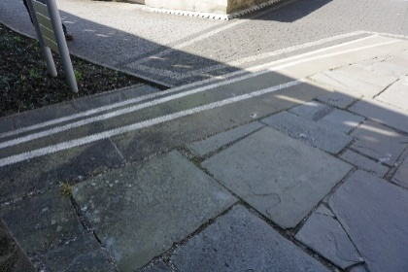
- Singleton Abbey. At side of the entrance, there is nothing to indicate the presence of steps for visually impaired people. Tactile paving slabs need to present to prevent falls.

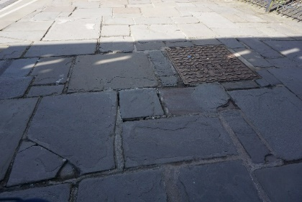
- Singleton Abbey. On the path into the abbey, there are broken and loose paving slabs which can cause people to trip and fall.

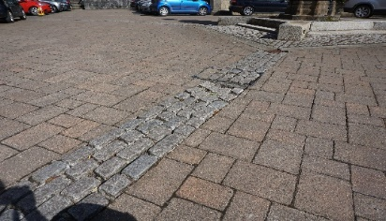
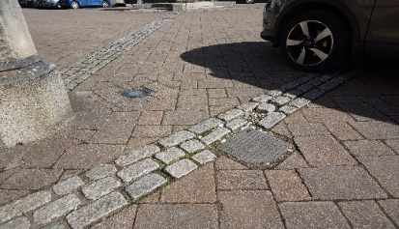
- Singleton Abbey. At the main door, a number of paving stones are loose and have caused the walkway to become uneven. This causes a trip hazard for both disabled people and able bodied people. This could also be hazardous for wheelchair users as wheels can get stuck in the depression between the paving stones.

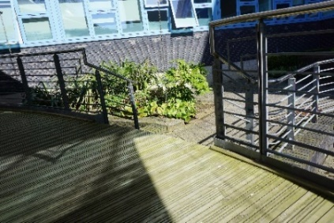
- Keir Hardie. On the ramp into the building, there are stairs which go off the side of the ramp which do not have the tactile paving stones, there is no indication of the presence of steps to a visually impaired person.

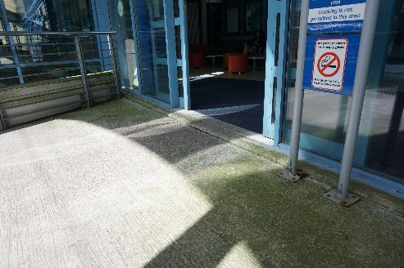
- Keir Hardie. There is a step at the door into the building, it is approximately 1.5 inches high, this is a trip hazard and makes getting into the building difficult for wheelchair users.

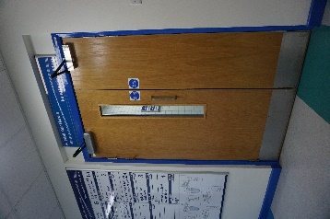
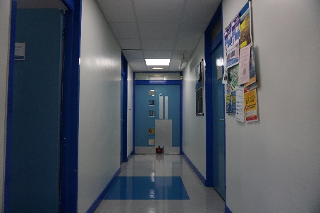
- Keir Hardie. The doors are very heavy and are not power assisted. This can make it very difficult for wheelchair users and other with mobility issues to open the doors independently.

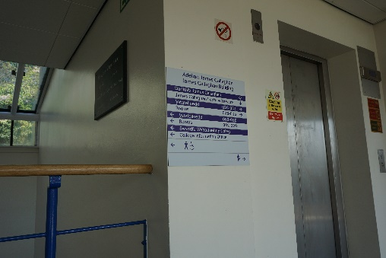
- James Callaghan Building. The signs do not have braille on them, this may make it difficult for visually impaired students to find their way around campus.

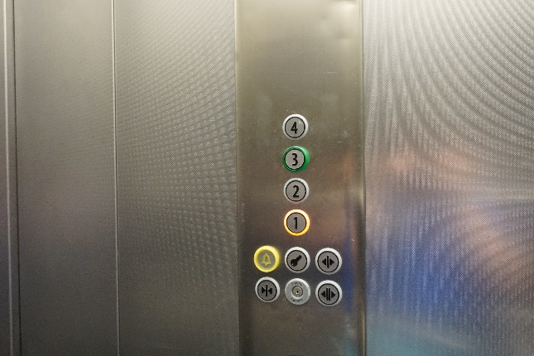
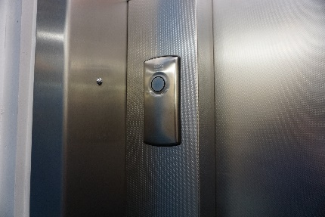
- Library. The lift does not have braille on the buttons inside or outside of the lift.

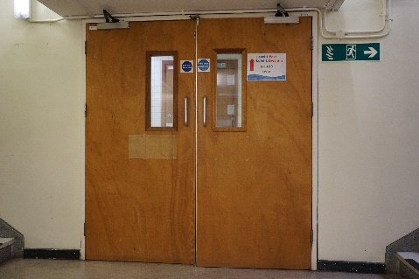
- Library. The doors on the 1st floor are difficult for wheelchair users to open as they are heavy and have very high handles.

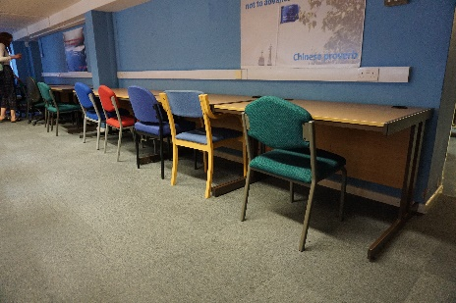
- Library silent study area 1st floor. There are no height adjustable desks in this area of the library, some wheelchair users may need a desk which can be adjusted to accommodate their chair.

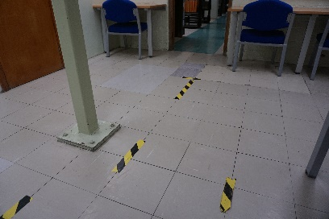
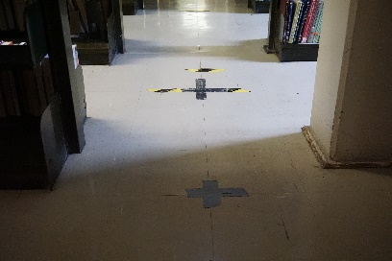
- Library both 1st floor and 2nd floor. Damaged floor tiles have been tapped down and not repaired fully. Some areas of the tape have become loose and are a trip hazard.

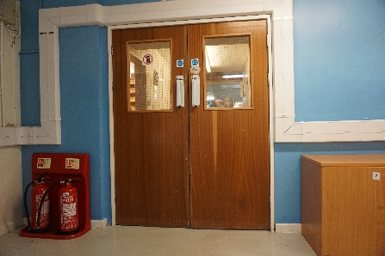
- Library. 2nd floor, the doors to the photocopiers are heavy and the handles are out of reach of wheelchair users.

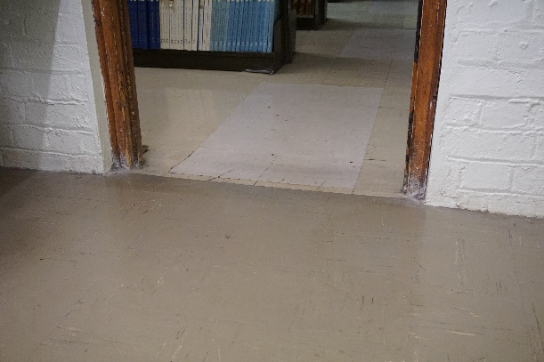
- In the library. 2nd floor west, there is an unmarked slope which could cause people to trip or fall, it is also quite steep for wheelchair users.

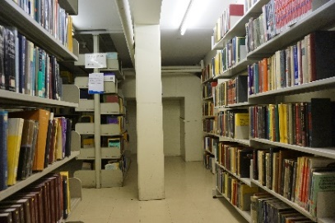
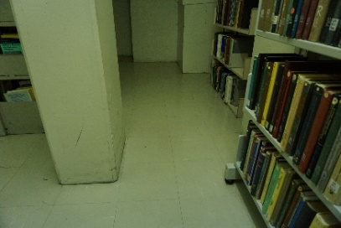
- Library. 2nd floor west, shelves have been placed too close to a pillar, as a result, the gap people must go through to get to the books is too narrow for wheelchair users to fit through.

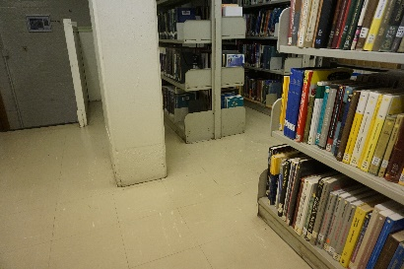
- Library. 2nd floor west, shelves have been placed too close to another pillar which prevents students in wheelchairs from getting through.

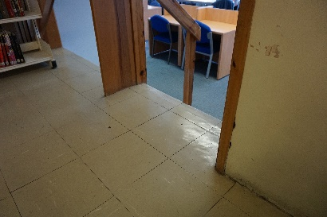
- Library. There are unmarked steps to a study area on the 2nd floor, this may lead to falls.

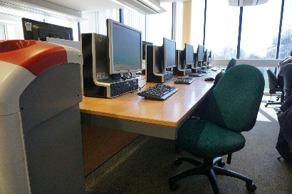
- Library. 4th floor PC room, there are no height adjustable desks and some wheelchair users may struggle to use the computers due to the size of their chairs.

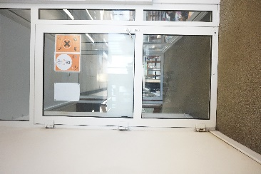
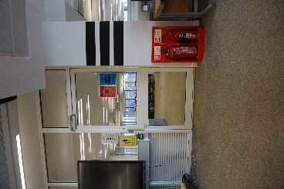
- Library. 4th floor PC rooms, the doors are heavy and difficult to open if a wheelchair user.

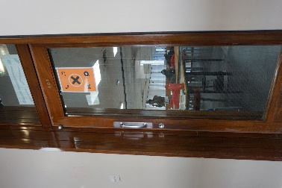
- Library. 4th floor, the door to access the postgraduate study area is heavy and difficult to open for wheelchair users.

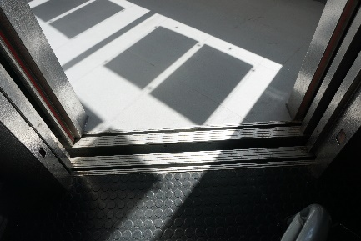
- Taliesin. The lift has a drop of at least 1 inch when on the ground floor. This can make leaving the lift difficult if in a wheelchair as there is a step to get over.

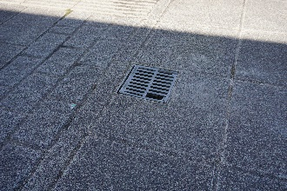
- Taliesin. By the entrance on the 1st floor of the building there is a loose drain cover. This could cause people to trip and wheelchair wheels could get caught.

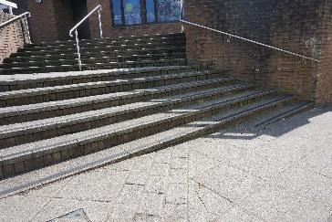
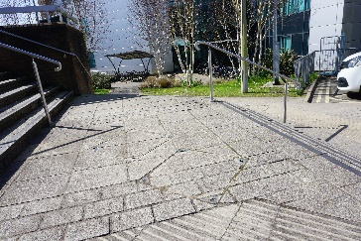
- Taliesin. At the back of the building there are some stairs which do not have tactile paving stones.

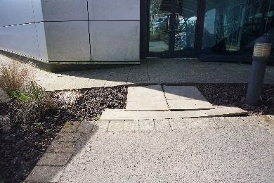
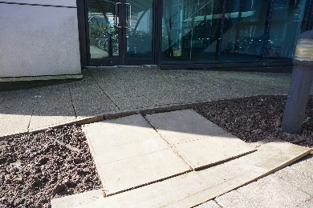
- Digital Technium. By the fire exit at the rear of the building, there is a path made of wooden panels which is not level and has a step leading up to the pavement. As people use this to access the bike rack and it is by the fire exit, a proper path needs to be installed to prevent the risk of injury.

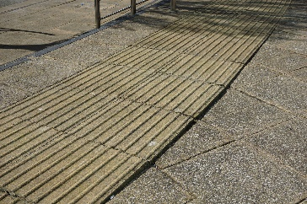
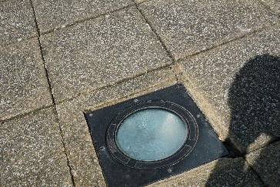
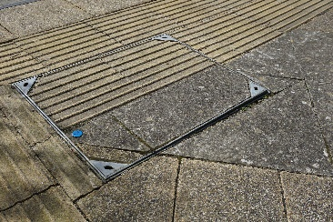
- Digital Technium. There are a number of loose and broken paving slabs outside of the building, many of which have created trip hazards. Some of the loose paving slabs are near the top of the stairs leading the building and there is potential for people to fall down them if they trip.

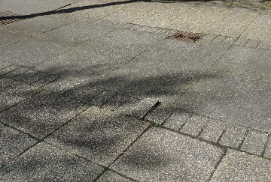
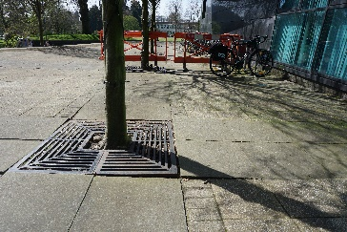
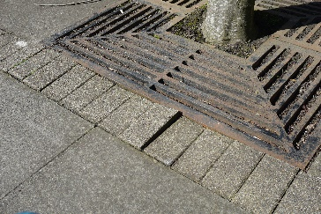
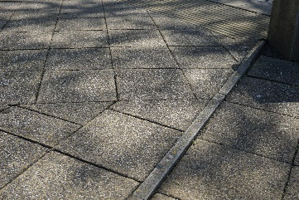
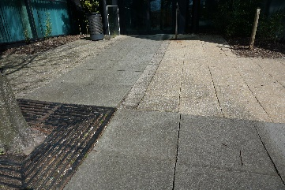
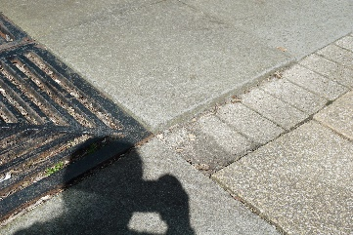
- Digital Technium. Outside the entrance to the building there are a number of loose paving stones which create a number of trip hazards and areas that could cause problems for wheelchair users.

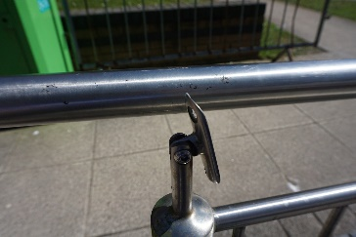
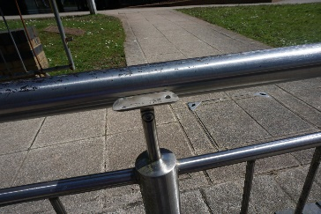
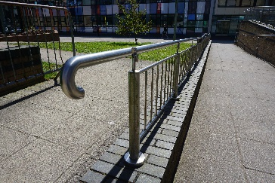
- Digital Technium. The railing on the ramp going up to the digital Technium is not attached and is not safe for use. For people with mobility issues who rely on the use of railings such as these, it could lead to falls and injuries.

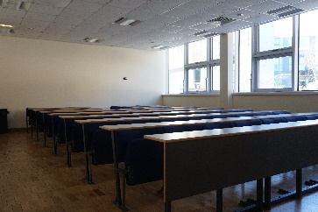
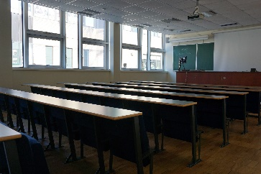
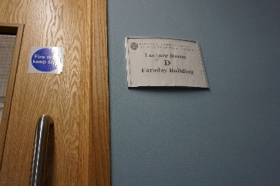
- Faraday building. Lecture rooms, B, C, D, E, F, G, H and J do not have space to accommodate students in wheelchairs.

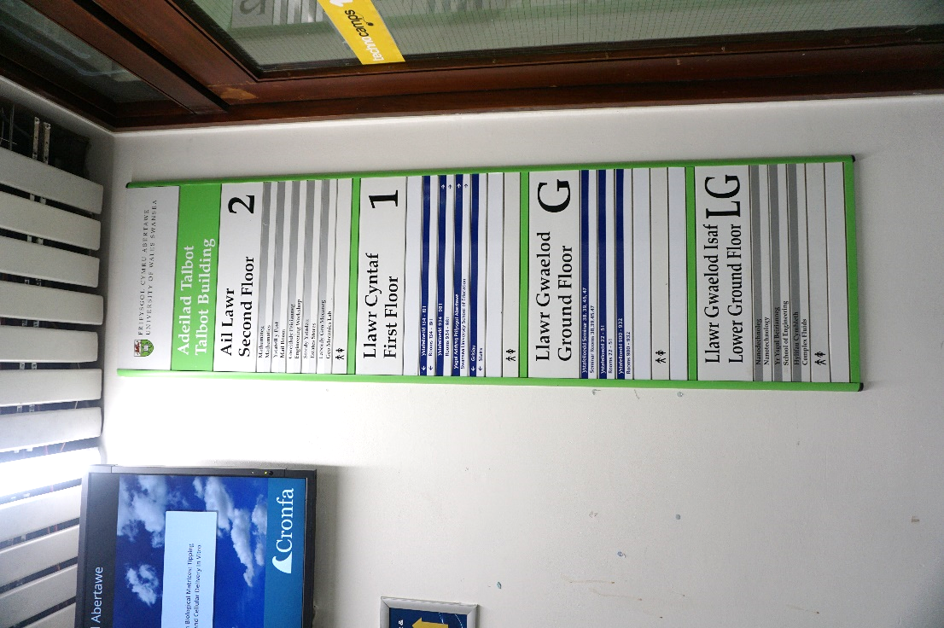
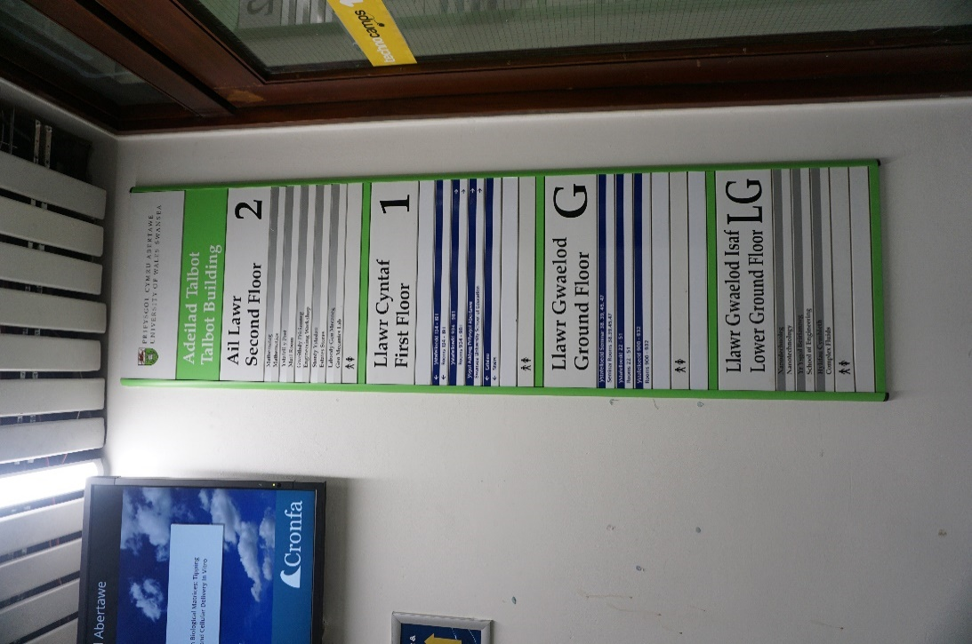
- Talbot Building. This building lacks basic facilities that would make the building accessible. There is no lift and there are no disabled toilets in the Talbot building. In order to access other levels of the Talbot building students have to cross into the faraday building.

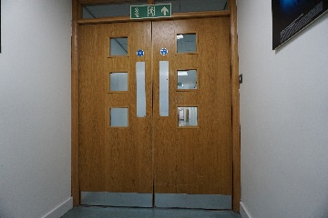
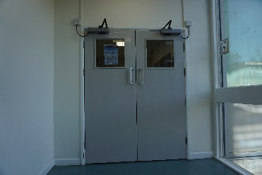
- Talbot Building. The doors throughout the building are very heavy and need power assistance. The handles are also very high and out of reach of people in wheelchairs, as a result they cannot use them and have to pull the doors which are damaged and splintering.

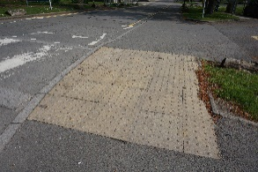
- Talbot Building. On the crossing towards exit of the university, tactile paving stones are broken.

- Talbot Building. Path around the back of Talbot building does not have a proper crossing. The dropped kerb is next to a drain and is not level. This makes it difficult to get across. It also does not have tactile paving stones.
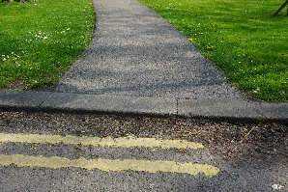
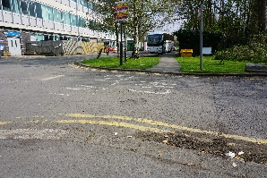
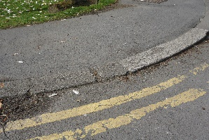

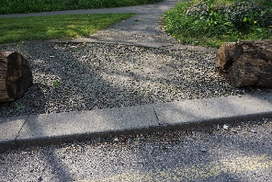
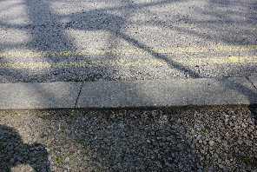
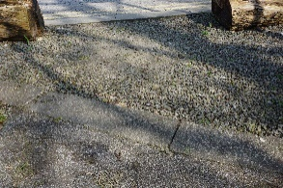
- Talbot Building. There is not a crossing to get from the side of the carpark to the Talbot building. The only area available in which to cores is highly unsuitable. It does not have a dropped kerb, it does not have tactile paving stones, and the area is covered in stones and is not properly paved. It is very unsafe for anyone and is nearly impossible to cross the road if in a wheelchair.

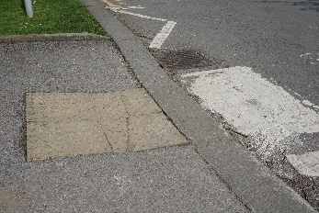
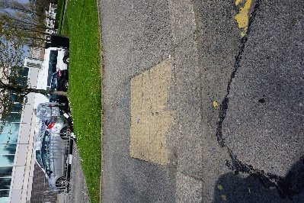
- Talbot Building. Crossing near the entrance on the lower floor of Talbot is not level and the paving stones are broken and unstable.

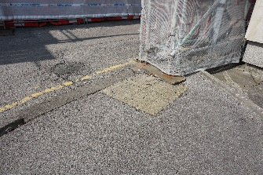
- Talbot Building. Crossing to get from rear side of the library to the Talbot building is not level and has pot holes in the road.

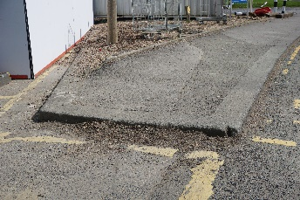
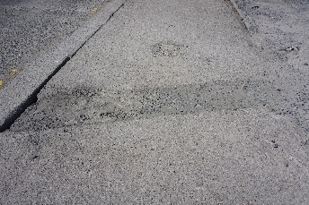
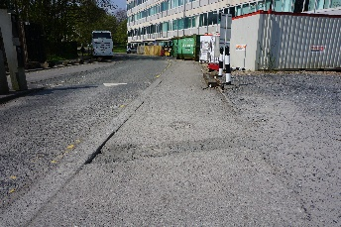
- Pavement behind Talbot building is not level and is difficult to wheel on, may also be difficult to walk on. This pavement also does not have a dropped kerb or tactile paving stones. As wheelchair users would not be able to cross to the side of the carpark wheelchair users and people with limited mobility are forced to stay on the road until they reach a safe and lowered pavement.

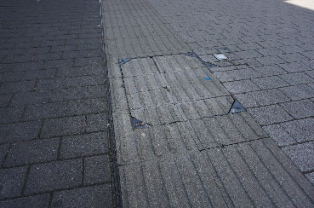
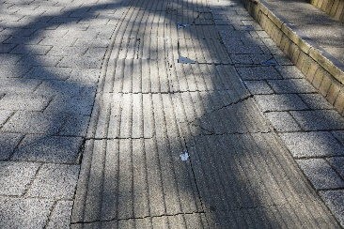
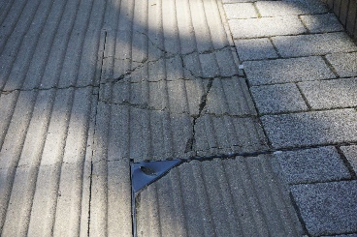
- The Mall. Outside of Faraday and the Digital Technium, there are many broken paving slabs which are unstable and uneven.

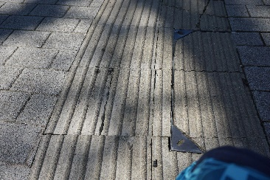
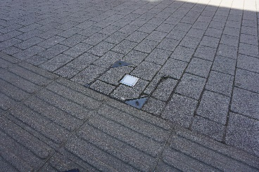
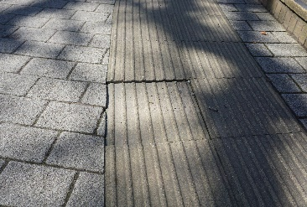

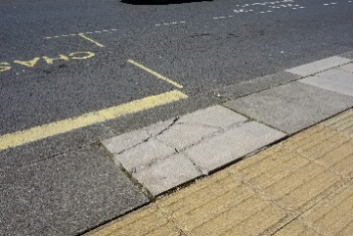
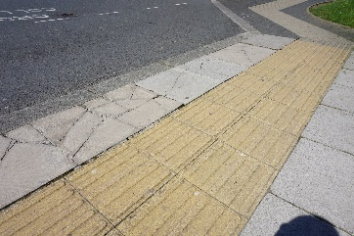
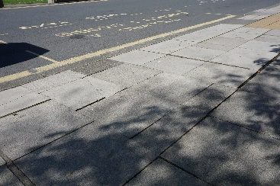
- Taxi pick-up area opposite Fulton House. Almost all of the paving slabs are broken, loose and unsafe.

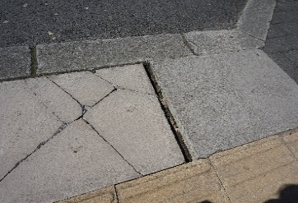
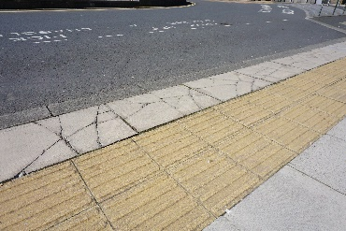
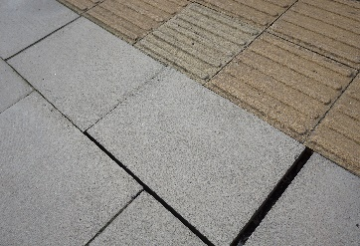

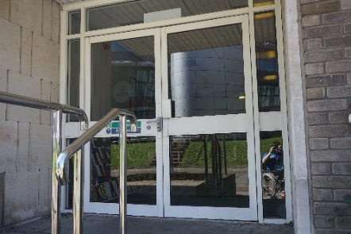
- Fulton House. On the right side of the building, there is a door to campus catering, the door is not automatic and is heavy and difficult to open.

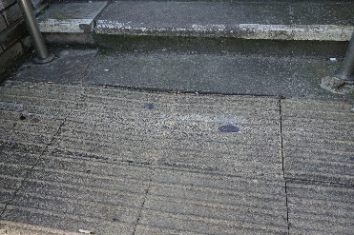
- Fulton House. The steps leading up to the door to campus catering has tactile paving stones which are uneven and cause pose a trip hazard.

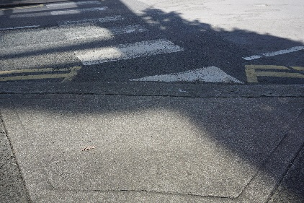
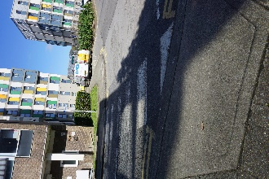
- Fulton House. Behind Fulton house there is a crossing to get to the back of Union house, opposite the Penmaen building, this crossing does not have tactile paving stones. Therefore, students with visual impairments may not be aware that there is a road there. Given that this road leads to the car park behind Taliesin and has a lot of traffic throughout the day, there is a risk to students.

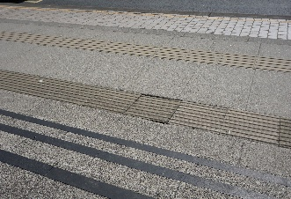
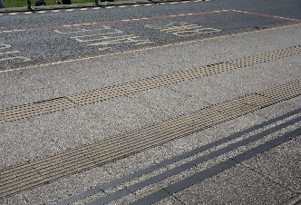
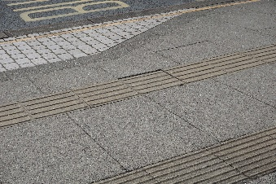
- Fulton House. On the pavement where the buses stop in front of Fulton house, there are numerous broken and unstable paving stones.

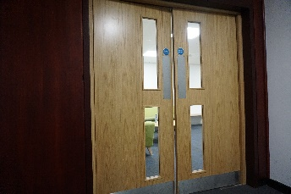
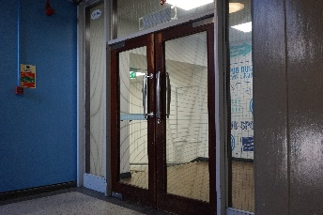
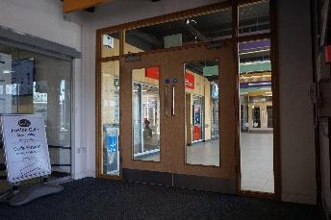
- Fulton House. The doors in Fulton house are heavy fire doors, these should be power assisted as they are difficult to open when in a wheelchair.

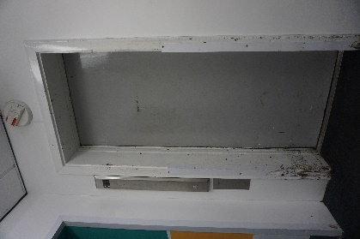
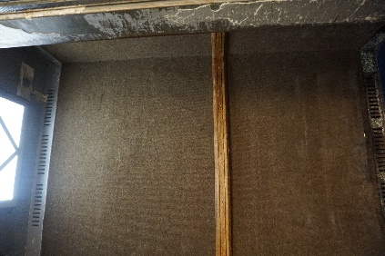
- Fulton House. The lift is in very poor condition both inside and out. The walls inside the lift have carpet falling off the walls and many areas of damage. The exterior doors need paint and there are areas of the wall by the door which need plastering and painting.

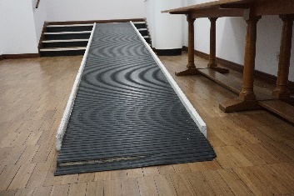
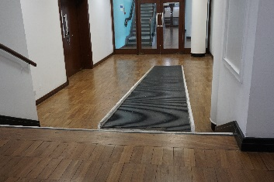
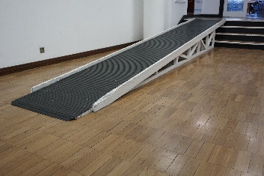
- Fulton House. 2nd floor, to access the other side of the building, wheelchair users must use the ramps which have been placed over the stairs. The lifts are very steep and do not have railings down the sides to prevent people from falling as these may not only be used by people in wheelchairs but anyone with a disability. Parts of the ramps are also damaged and are in need of repair.

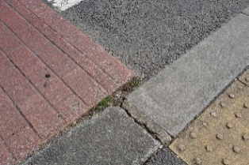
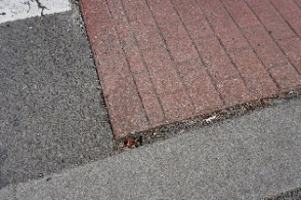
- Outside Fulton House. The crossing from Fulton house to the Grove building has gaps between the raised crossing and the pavement. Wheelchair wheels could get caught in this gap and this could lead to the chair tipping over. This could lead to serious injury.

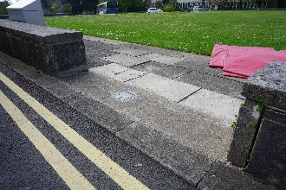
- Fulton House. There is not a safe crossing onto the grass area in front of Fulton House, needs a zebra crossing with tactile paving to ensure students are not at risk from vehicles.

- Fulton House. Paving stones surrounding the lawn are in a state of disrepair and need complete renovation. They are broken, unstable and make walking and wheeling around the lawn very difficult and unsafe. AS this area is commonly used for events in the university, it is imperative that these paving stones are replaced and made a more suitable for their function.
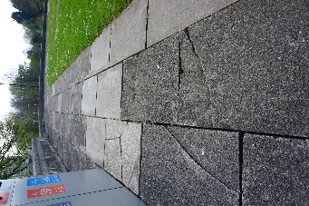
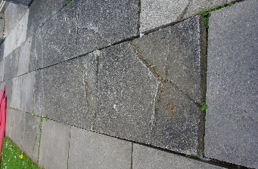
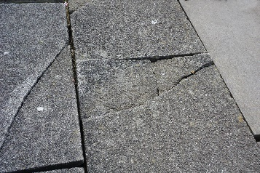

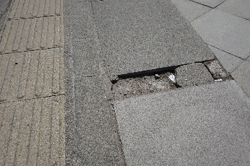
- Bus Stop by Grove building. There is a paving stone missing from the pavement and therefore there is a large gap at least 1 inch deep. This could cause people to fall over, or could cause wheelchairs to tip over.

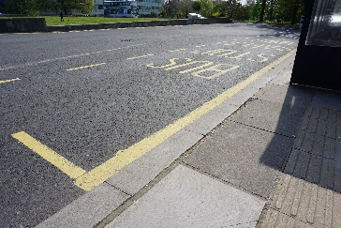
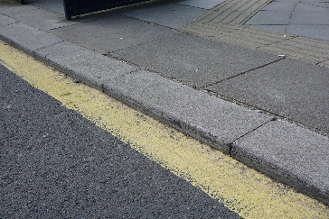
- Bus Stop by Grove building. The kerb at the bus stop is too low for buses. Wheelchair users are not able to get on buses without assistance as even if the buses lower their ramp, it is too steep to get up. The pavement needs to be higher so that there is level access to the buses.

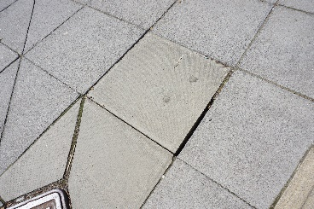
- Bus Stop by Grove building. There are loose paving stones which need to be stabilised to prevent risk of injury.

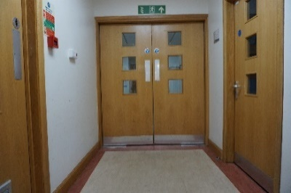
- Grove Building. The doors throughout Grove are heavy and need power assistance. They also have high handles which makes it difficult to open them if in a wheelchair.

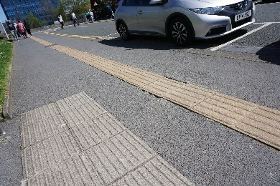
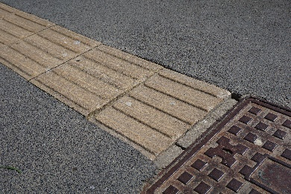
- Grove Building. Outside the building, there are several broken and loose paving stones.

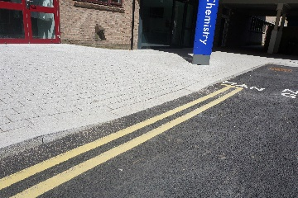
- Grove Building Extension. By the entrance to the Chemistry department, there is a dropped kerb, but it does not have any tactile paving stones. This dropped kerb leads onto a road and this needs to be clear to visually impaired people.

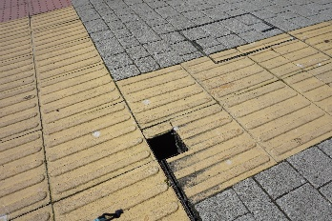
- Glyndwr Building. There is a 4 inch x 4 inch hole in the pavement which is 6 inches deep. This is a serious hazard for anyone using the pavement.

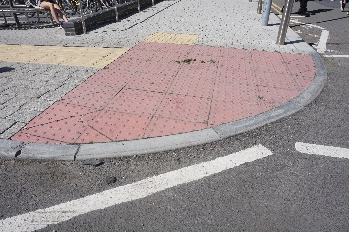
- Glyndwr Building. The crossing from Grove to Glyndwr is not level and despite work to make it so, it is still difficult for wheelchair users.

- Glyndwr Building. On the pavement which leads up the side of the building, there is a dropped kerb which does not have any tactile paving stones and it not level with the road making it difficult for wheelchair users to get on/ off the pavement. There is also a pot hole on the road near to the lowered kerb and this is a hazard.
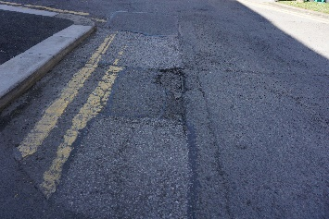
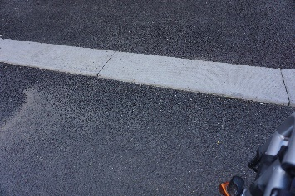

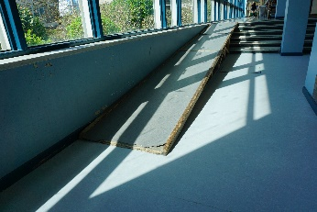
- 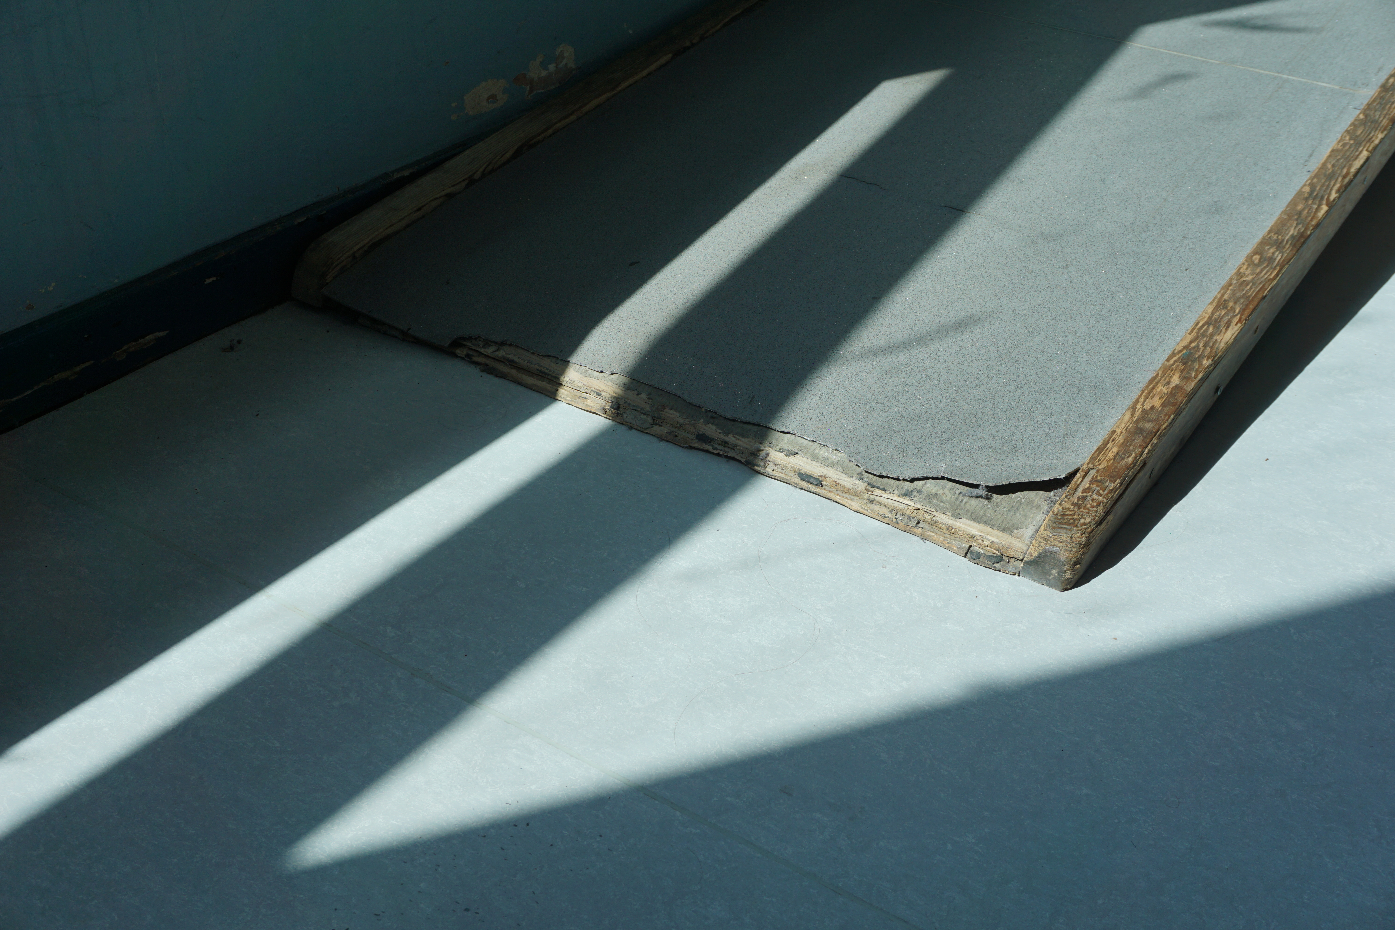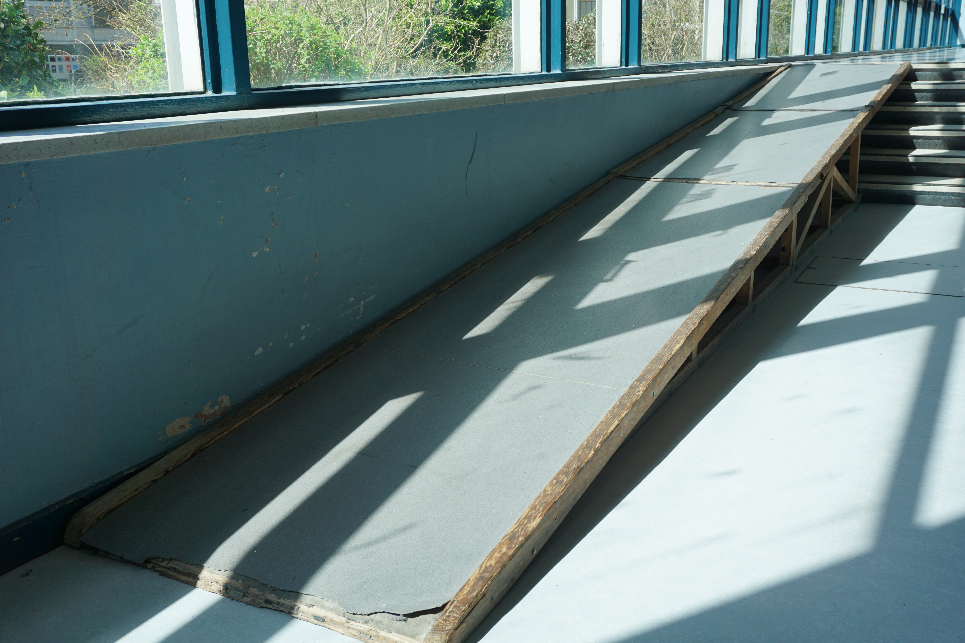Glyndwr Building. Ramp in the corridor to access Vivian Tower, has a lot of damage to the bottom of the ramp making it difficult for wheelchairs to get onto the ramp.

- Vivian Tower. Outside the entrance to Vivian Tower next to the Sports Science Laboratory, the pavement is very uneven, difficult to walk across and could cause falls. In addition to this, the only pavement to access the building is obstructed by cars and as a result wheelchair users are forced to use the road which is very unsafe.
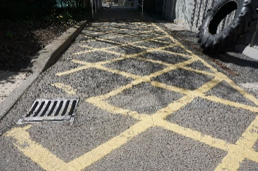
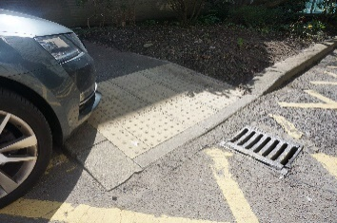
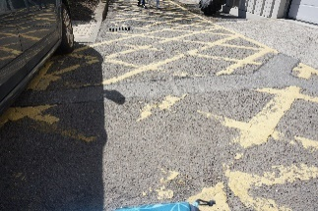

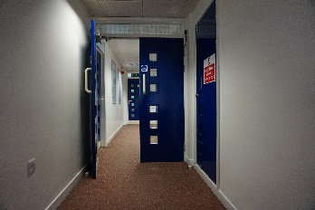
- Vivian Tower. The doors throughout the building are too narrow to fit a wheelchair throughout without opening both doors. This makes it difficult for wheelchair users to get around the building independently.

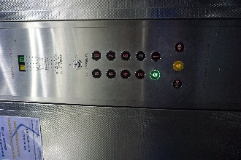
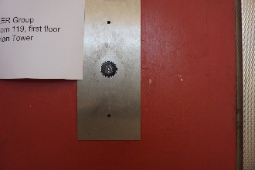
- Vivian Tower. The lifts do not have braille on either the interior or exterior buttons.

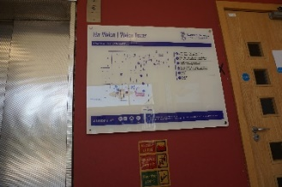
- Vivian Tower. The signs showing where the lecture rooms are in the building do not have braille and visually impaired students may struggle to find their way around the building.

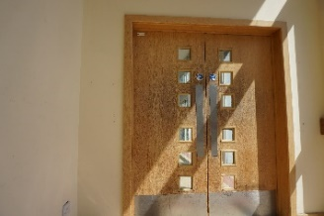
- Vivian Tower. The doors are also very heavy and need power assistance to allow people in wheelchairs to get around the building independently.

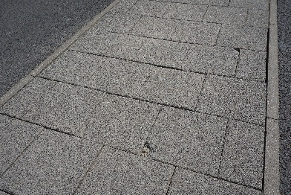
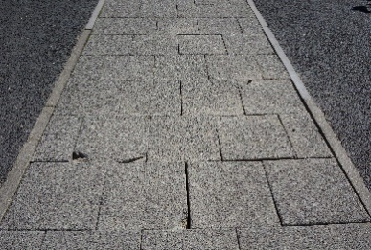
- Outside Data Science Building. Pavement has many broken paving stones which are unstable.

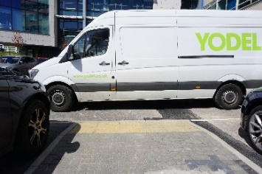
- Outside Data Science Building. Dropped pavement for people to get into the car park or to access the data science building is often obstructed by vehicles, also common at the crossing by the Amy Dillwyn building. These vehicles prevent people in wheelchairs from crossing the car park and could be hazardous to people with visual impairments. Double yellow lines may be required to prevent vehicles parking on crossings.

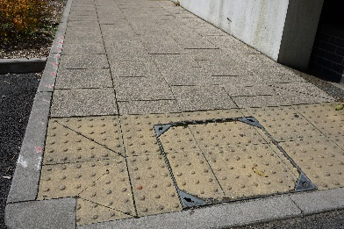
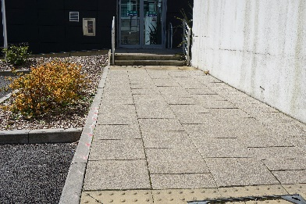
- Outside ILS2. There is a path with 2 steps going from the side entrance of the ILS2 building to the car park beside Glyndwr. This path is long enough to have a ramp instead of steps, but because it has steps, wheelchair users are forced to wheel a much further distance which involves a steep hill. This can be difficult for wheelchair users.

- Glyndwr Building to ILS2. The crossing from Glyndwr to ILS2 has tactile paving stones which are all cracked, wobbly and unsafe. These could easily cause falls and injuries.
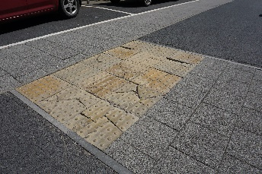

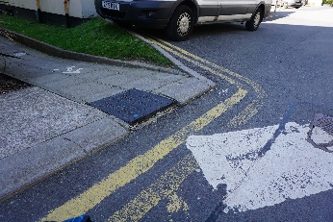
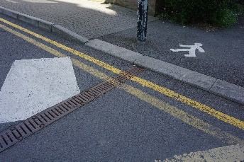
- Glyndwr Building to ILS1. The crossing to get from Glyndwr to ILS1 has a large drop on one side and the other side does not have a dropped kerb or tactile paving stones.

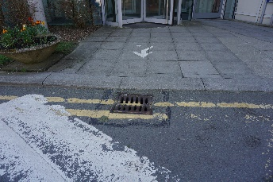
- ILS1 to the Wallace Building. The crossing is not suitable for wheelchair users. The side of ILS1, the crossing has been put in front a drain, wheelchairs may struggle to get across the drain as wheels can become stuck in drains. The kerb has also not been lowered and it is quite high. This makes it tough to get on or off the pavement.

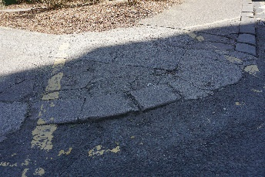
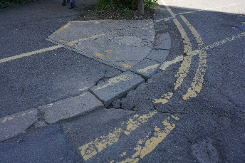
- Wallace Building to Glyndwr. There is not a proper crossing to go from Glyndwr to Wallace. The corners of the pavement which are used as a crossing by most students are in need of repairs and do not have tactile paving stones.

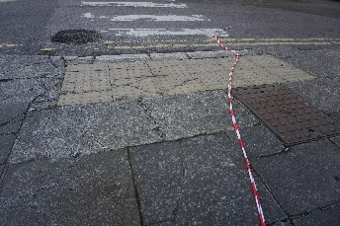
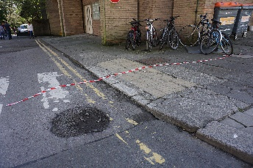
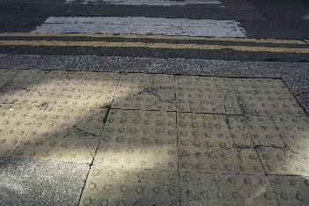
- Margam Building. The crossing to get from the Wallace building to the Margam building is damaged and most of the paving stones are broken and unstable. There is a large pot-hole in the crossing which poses a risk to all people who use the crossing. The kerbs are also too high to allow wheelchair users to cross easily.

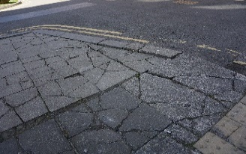
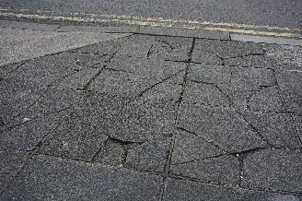
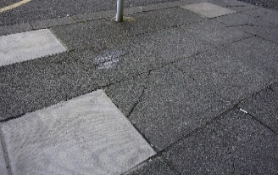
- Margam Building. The paved area in front of the building is highly damaged and requires renovation. The paving stones are almost all broken and many are unstable and unsafe.

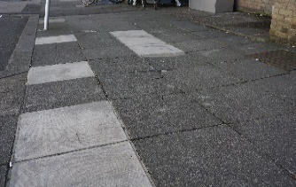
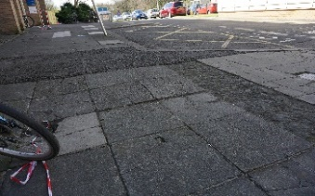
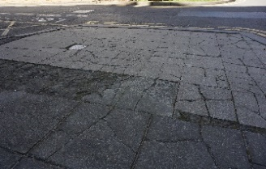

- Margam Building. The lift in the building does not have braille on the buttons.
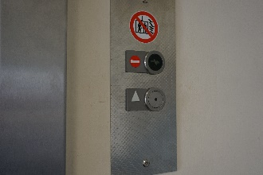
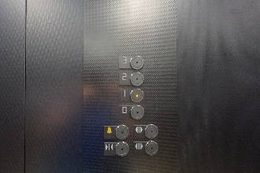

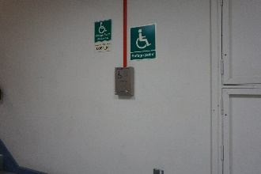
- Margam Building. The refuge point for wheelchair users does not have any information on where to find an evac-chair. A sign needs to be installed to show where the evac-chair can be found or an evac-chair needs to be installed on the first floor.

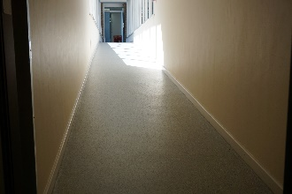
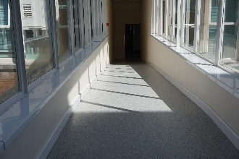
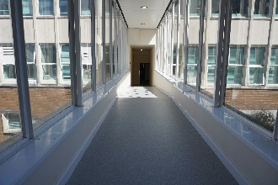
- Margam Building – Wallace Building. The walkway which connects the two buildings is not safe, the ramp is 2 steep and there are not railings to give people walking down the ramp support.

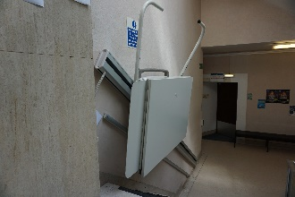
- Wallace Building. The stair lift to access the Wallace Lecture theatre does not work and has no signs showing that it is out of order. This lift needs to be repaired to allow students who use wheelchairs to access the lecture theatre.

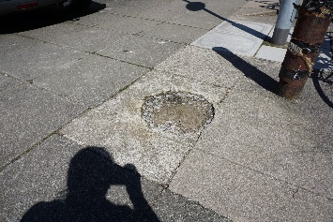
- Wallace Building. Outside the main entrance there is a pot-hole in the pavement. It is around 2 inches deep and is a serious hazard to anyone who uses the pavement.

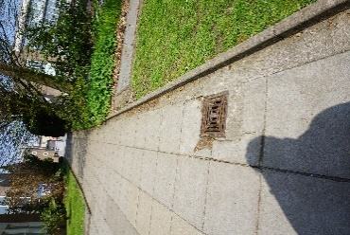
- Wallace building. On the pavement at the side of the building there is a hole beside a drain. This is a hazard for anyone who uses the pavement.

- Wallace to Grove. On the crossing which goes from the side of the Wallace building to the grove building there are several broken and unstable tactile paving stones.
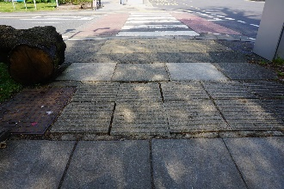

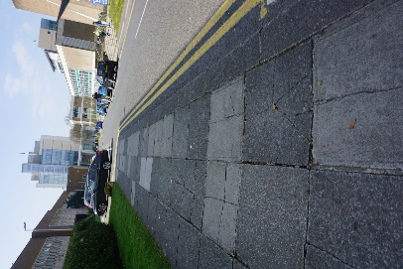
- Wallace building. The pavement going towards the building there are many unstable paving stones.

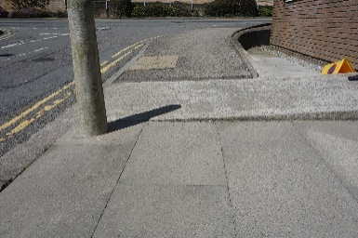
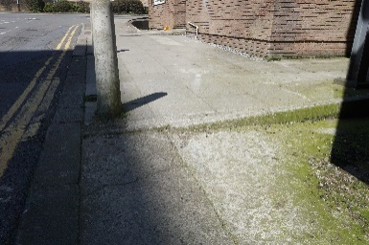
- Amy Dillwyn Building. On the pavement outside the rear entrance of the building, there are steps going across the pavements and a raised area for loading goods into the building. These prevent wheelchair users from using the pavement and they are then forced to use the road which is not safe.

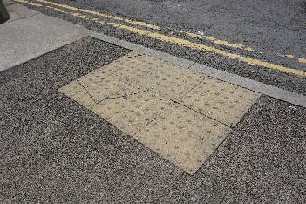
- Amy Dillwyn Building. The crossing by the back of the building which is opposite to the Haldane building has several broken paving stones which are not secure.

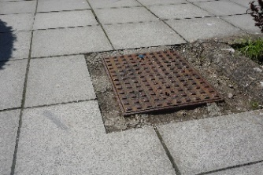
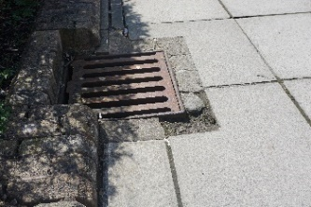
- Haldane Building. There are two drains on the pavement leading up to the main entrance, both have large holes around them and are a risk to people walking on the pavement and to people who use wheelchairs.

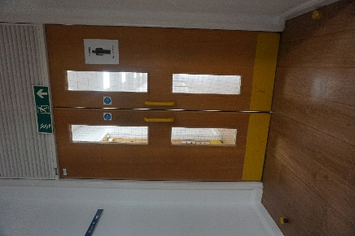
- Haldane Building. The doors throughout the building are too narrow and too heavy. This makes the doors very difficult to open if in a wheelchair.

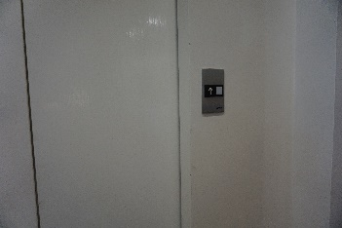
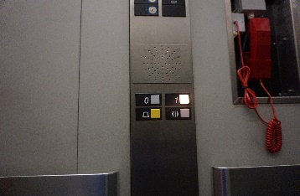
- Haldane Building. The lift does not have braille on the interior or exterior buttons.

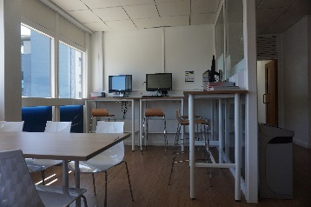
- Haldane Building. The computer area on the 1st floor does not have an area of computers for people in wheelchairs, only people who are able to stand and sit on the stools can use the computer area.

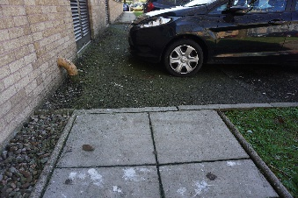
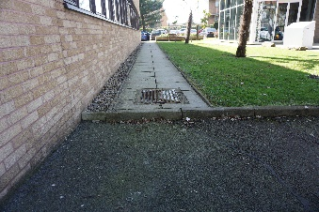
- Haldane Building. The path behind Haldane has two large kerbs either side of a road which had parked cars on it. These large kerbs prevented safe access to the Hillary Clinton Law School for wheelchair users. As a result, wheelchair users are forced to go through the car park where they are at risk of being hit by vehicles.

- Haldane Building. After speaking with the staff it was found that the building does not have T-Loops in reception or in its lecture rooms. It was also found that accessing T-Loops when they are needed is very difficult. Staff have been sent to and from several departments before being able to get one. This means they are not available on demand for those that need them.
- Hillary Clinton Law School. The path into the building is not level and this makes it difficult for wheelchair users to get into the building.
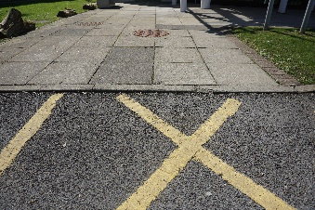

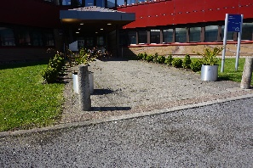
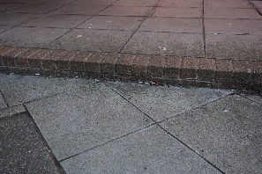
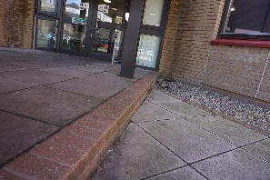
- Hillary Clinton Law School. The entrance in the middle of the building is not accessible. There are large steps either side of the door and the path to the front leads into the car park and is therefore not safe.

- Hillary Clinton Law School. The fire exit at the rear of the building leads out onto a flight of stairs which makes it inaccessible for wheelchair users. It also does not have tactile paving stones.
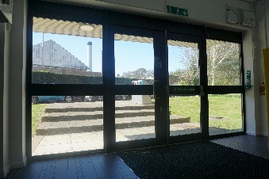

- Hillary Clinton Law School. After speaking with reception staff, it was found that the law school also does not have a T-Loop available on demand. Any staff/ students/ visitors would also not have access to the equipment unless it was requested in advance.

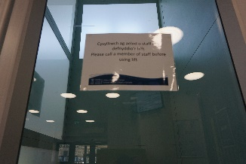
- Hillary Clinton Law School. The lift in the building has a sign on it that it cannot be used without a member of staff, this could make it difficult for wheelchair users to get to the 1st floor and back to the ground floor if staff members aren’t available at all times.

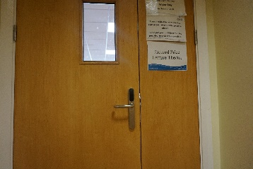
- Hillary Clinton Law School. The Richard Price Lecture theatre does not have wheelchair friendly seating.

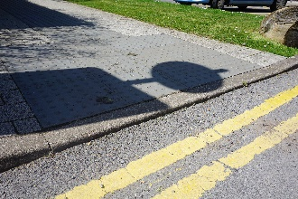
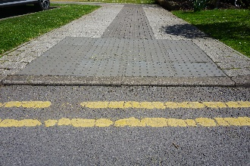
- The crossing from Preseli to Cefn Bryn is not level and makes it difficult for people in wheelchairs to cross the road.

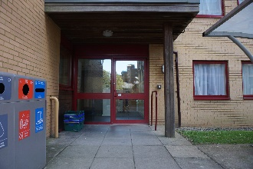
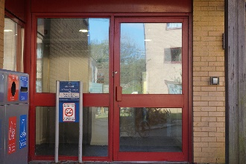
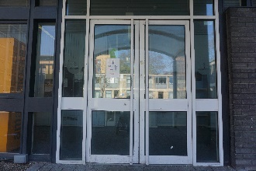
- Residences. The doors to servers of the residence buildings are too heavy to be opened by someone without issues or someone who uses a wheelchair. This includes; Cefn Bryn, Preseli, Caswell, Oxwich and Kilvey. This buildings need power assisted or automatic doors like the doors which have been installed in the Langland building.

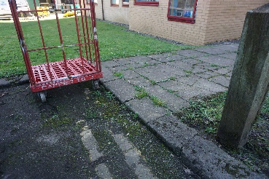
- Langland. The fire exit to the rear of the building has broken paving stones, a high kerb and the path is then obstructed with metal trolleys and a storage unit. This would make it very difficult for wheelchair users to evacuate the building in the event of a fire.

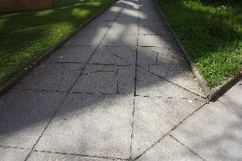
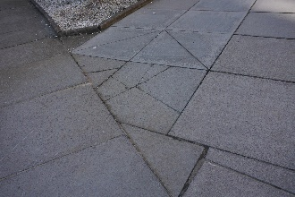
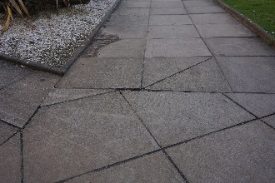
- Residences. Many paving stones on the paths to the residence buildings are broken and unstable. These are hazards to anyone who uses the paths and not only people with disabilities.

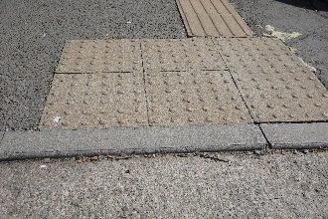
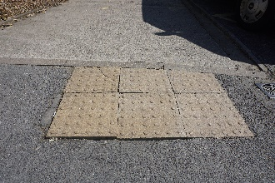
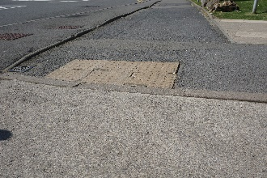
- On the pavement going to union house, there is a crossing on the pavement. This crossing has broken tactile paving stones and the kerb is not level with the pavement. As this pavement is on an incline, the raised kerb makes it very difficult for a wheelchair user to use the pavement.

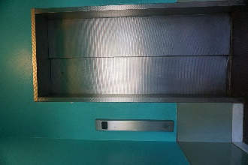
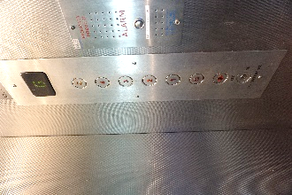
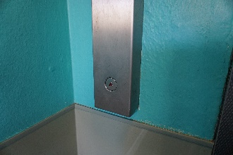
- Union house. The lift does not have braille on either the interior or exterior buttons.

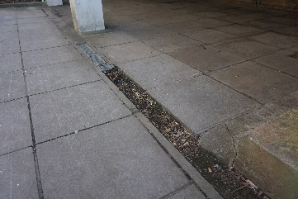
- Union house. There is a pavement down the side of the building, this path has a large hole where there is a missing drain cover. This could cause people to fall and injure themselves and could cause wheelchairs to get stuck and tip over.

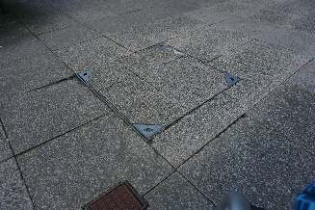
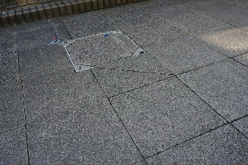
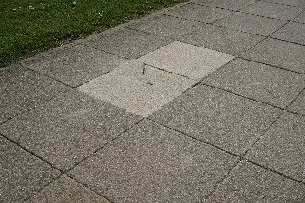
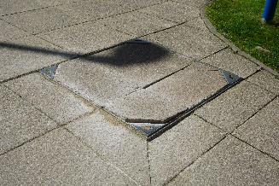
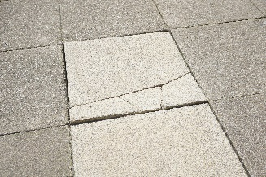
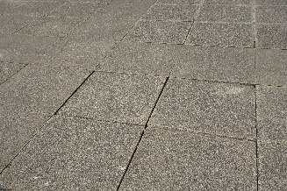
- Penmaen. The pavement in front of the building and around the back has many broken and unstable paving stones which could be a hazard to visually impaired people are anyone who has mobility issues.

- There is an access button outside of the SAS office. When tested the button did not open the door to the office.
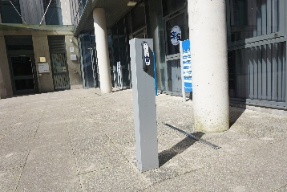

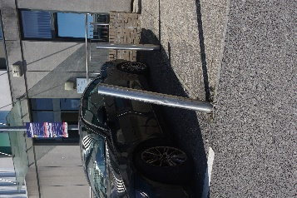
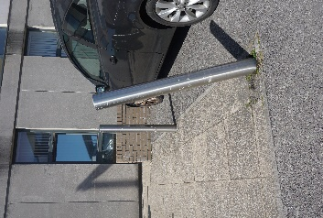
- Horton. Outside of the building where the pavement joins with the carpark, there are two metal posts, neither of them are secure and can easily be moved. Given how easily they can be moved it is possible that they will fall into the pavement and obstruct it.

Section B – Bay Campus
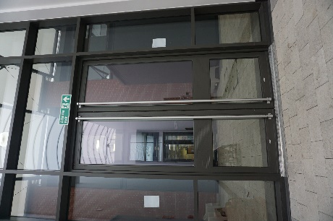
- Engineering Central. The doors throughout the building they are heavy and difficult to open for wheelchair users.

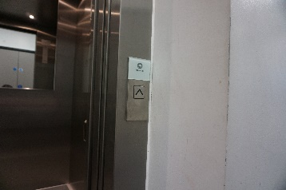
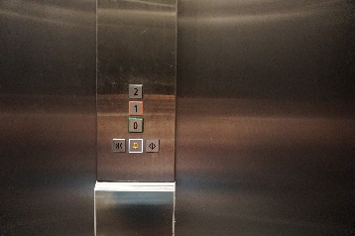
- Engineering Central. The lift does not have braille on either the interior or exterior buttons.

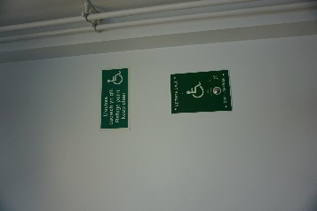
- Engineering Central. The refuge area for wheelchair users on the 1st and 2nd floor does not show where an evac-chair can be found. The evac-chair is on the ground floor but this needs to be made clear for emergency situations.
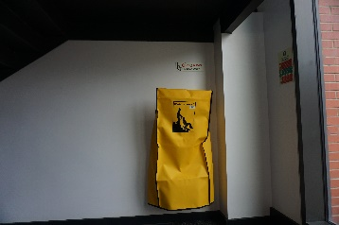

- Engineering Central. There is a work area in one of the corridors on the ground floor, there are several high desks but only one low desk that would be suitable for wheelchair users. However, this desk is not height adjustable to accommodate different size wheelchairs and the plug sockets have not been lowered and are out of reach of people confined to a wheelchair.
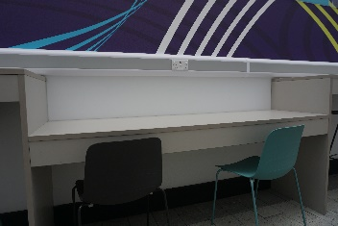
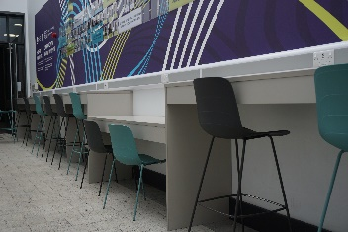

- Engineering Central. The reception area does not have a T-Loop available on demand for students/ staff/ visitors that require it.
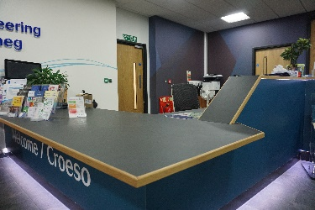
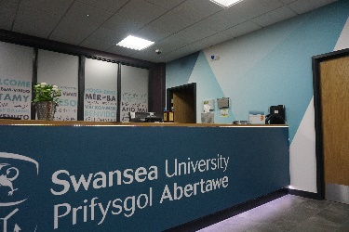

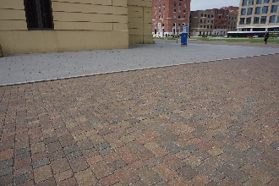
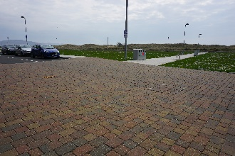
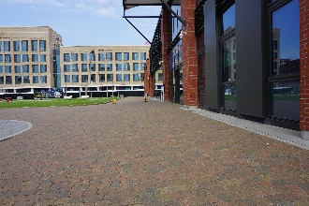
- Outside Engineering Central. There are no tactile paving stones to indicate to visually impaired people that there may be vehicles passing them. As most of the roads are level with the pavements, there is nothing to allow students to discriminate between a road and a walkway.

- Behind Engineering East. There is a high pavement which does not have a proper crossing to the other side where there is a seating area and where students can access the beach. This kerb is very high and students in wheelchairs or mobility issues have to go back to the library to find a level crossing, however, there are no tactile paving stones. There needs to be a dropped kerb on either side with tactile paving stones.
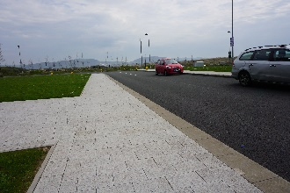
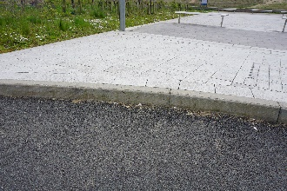
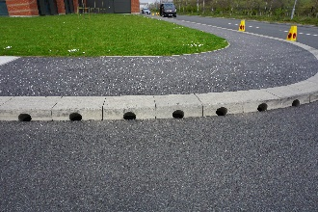

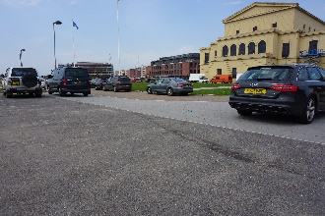
- 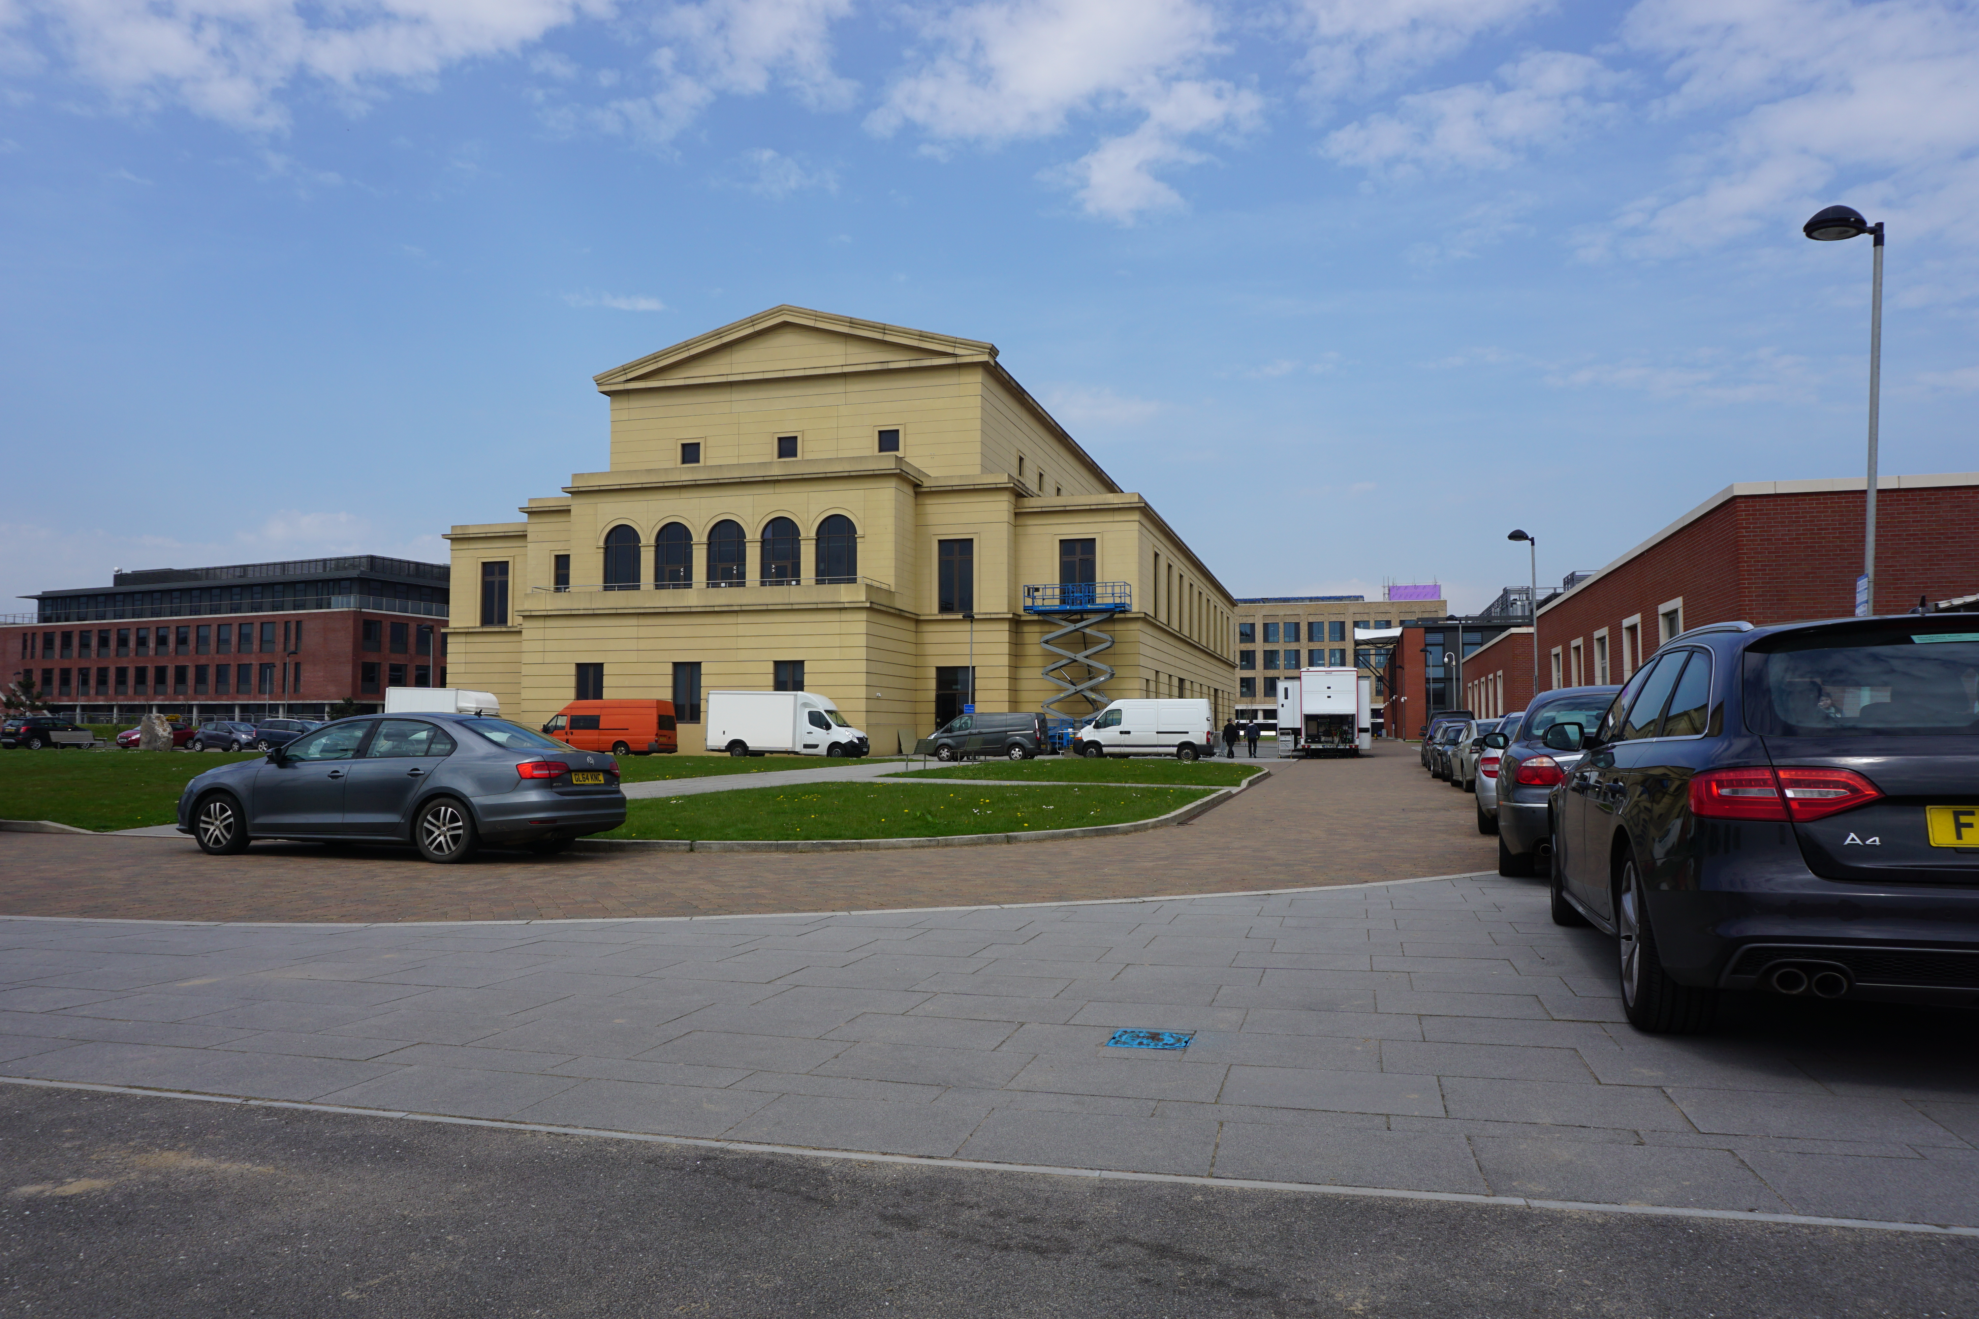Behind the Great Hall. There are no tactile paving stones to show where the pavements end and the roads begin.

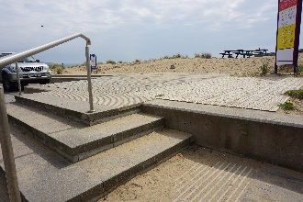
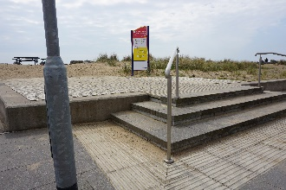
- Beach Access. There are steps up to the beach which have some railings, however, as there is a large drop at the side of the steps, there needs to be additional railings.

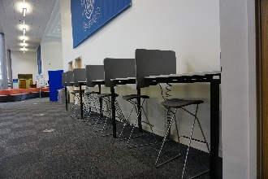
- Library. Working area to the left of the main door, the seats by the desks do not have back supports which may be needed by students with disabilities.

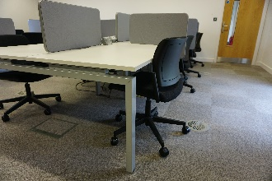
- Library. The silent study areas do not have height adjustable desks which may be needed to accommodate for larger wheelchairs.

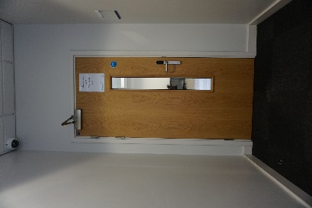
- Library. The doors to the study areas and PC rooms are heavy and difficult to open, they need power assistance.

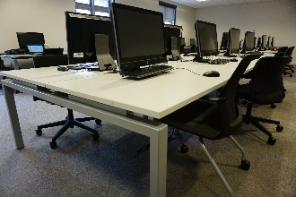
- Library. PC rooms do not have height adjustable desks, students in wheelchairs which need higher desks may not be able to use computers in the library.

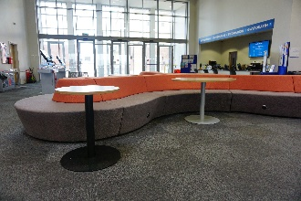
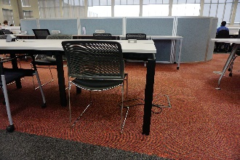
- Library. Desks in the main study area of the library are also not height adjustable and this may make it difficult for wheelchair users to work in groups with their peers.

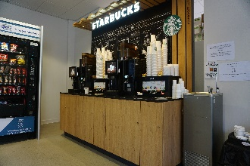
- Library. The coffee area is not wheelchair accessible, it high and does not have space underneath to allow for a wheelchair to go under it.

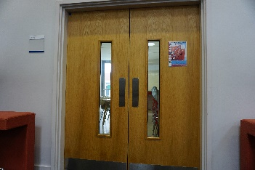
- Library. The doors into the coffee area are heavy and difficult to open, it would be even more difficult for students when carrying a drink and trying to open the door. These doors need to be power assisted or automatic.

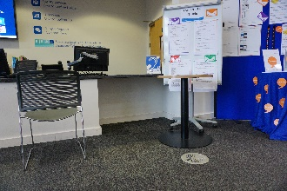
- Library. The reception area of the library has an area that allows wheelchair users to wheel right up to and under the desk. However, this area has been partially blocked by a table.

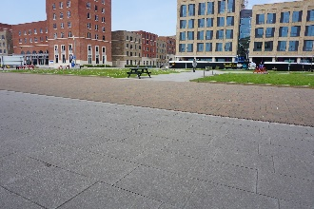
- Great Hall. Area in front of the building also does not have any tactile paving stones for visually impaired people. This area has a number of cars and other vehicles driving past throughout the day. People with visual impairments could really struggle to make their way around campus safely.

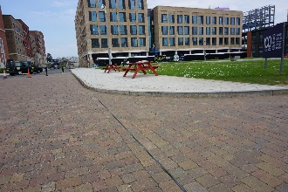
- Great Hall. There is no dropped kerb to allow people to access the benches opposite the building, those with mobility issues or those who use wheelchairs would need to go right around the area of grass to get to the benches.

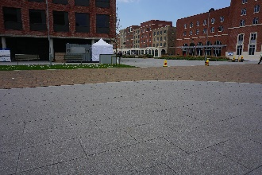
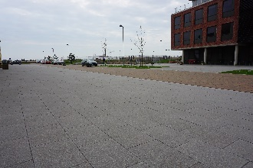
- Management Building. There is not a proper crossing from the Great Hall to the Management building. There needs to be tactile paving stones to allow people to cross safely.

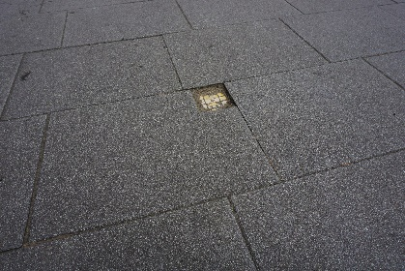
- Management Building. Outside the building there is a drop in the pavement which could be a trip hazard.

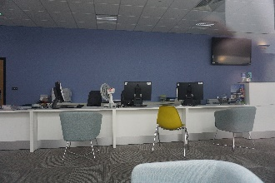
- Management building. The reception desk does not have a T-Loop available for people who require the use of hearing aids.

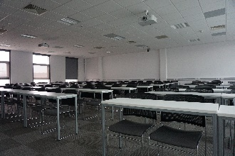
- Management Building. The lecture room in the building does not have space for a person who uses a wheelchair. A wheelchair user may find it very difficult to get access to a desk to use during a lecture.

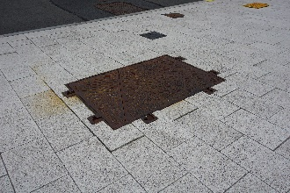
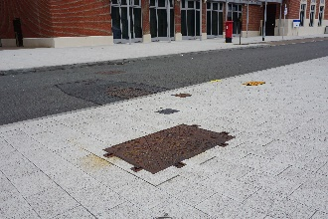
- Opposite MyUniHub. On the pavement opposite the MyUniHub, there a loose drain cover which could lead to future injuries.

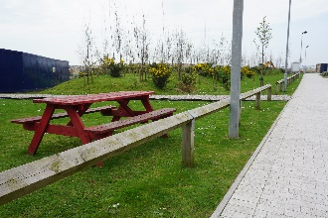
- Opposite 52°. There are benches on a grassy area behind a wooden fence. The only way to access them is on a path, which made up of stones and does not go to the benches. The path is not suitable for wheelchair users and they cannot use them.

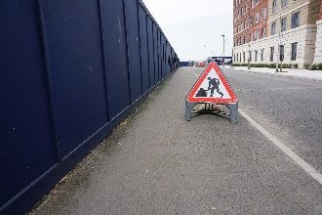
- Car Park 2. On the pavement leading to the large car park, there are construction signs which obstruct the pavement and prevent wheelchair access.

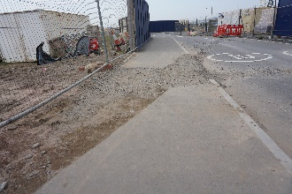
- Car Park 2. The pavement leading to the car park is not even and is difficult to wheel on and is dangerous to walk on.

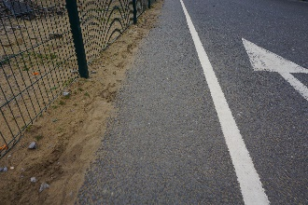
- Car Park 2. The pavement near the car park is very narrow and large wheelchairs may not fit within the painted pavement line. Those who use large wheelchairs may be forced to go on the road which puts them at risk.

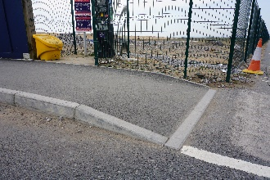
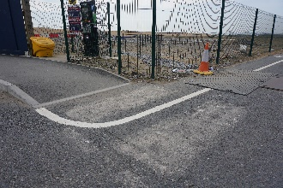
- Car Park 2. At the end of the raised pavement leading to the car park there is a very steep slope which is very difficult to wheel up.

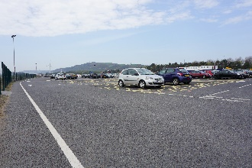
- Car Park 2. There is no safe crossing from the disabled bays to the pavement or to the pay and display machines.

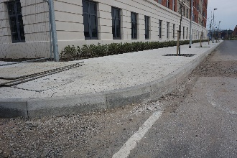
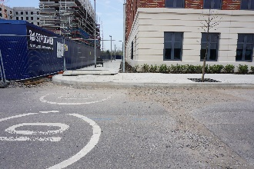
- Residences. There is a very large kerb towards the back of the residences rear the car park. It is around 8-10 inches high and is not accessible to wheelchair users.

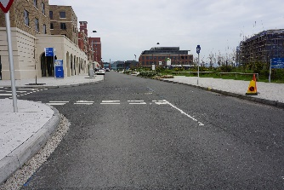
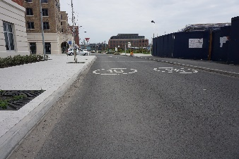
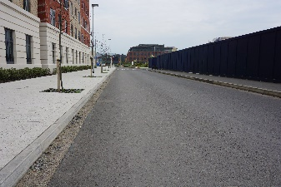
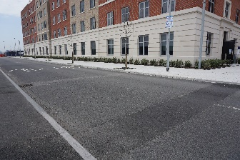
- Opposite Residences. There is only one crossing to get from the side of the management building to the residences. In order for wheelchair users or people with mobility issues to cross from one side of campus to the other, they have to go to the crossing by the MyUniHub.

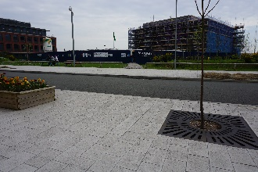

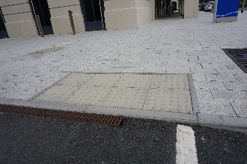
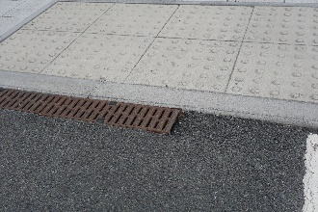
- The Core. At the crossing before The Core there is a drop next to drain which could cause wheelchairs to get stuck or cause people to fall.

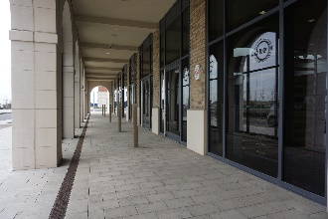
- The Core. There are no automatic doors into The Core which may make it difficult for people in wheelchairs to get into the building.

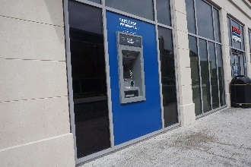
- Santander and Tesco. Neither Tesco or Santander have lowered cash machines, there needs to be a low cash point for wheelchair users.

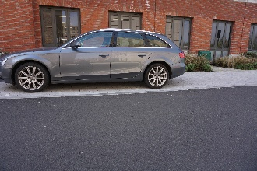
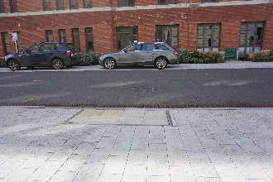
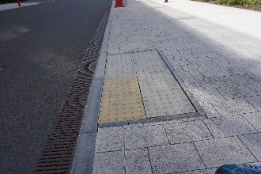
- Students Union. There is a dropped kerb with tactile paving stones on one side of the road but not the other. This is the bus route which means there is a high volume of traffic on this road. There needs to be a safe crossing for all people in the university. On the dropped kerb, there are several loose paving stones which could cause falls in people who are unsteady.

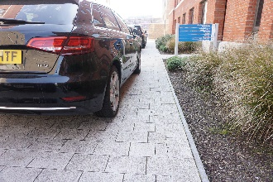
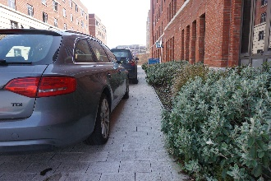
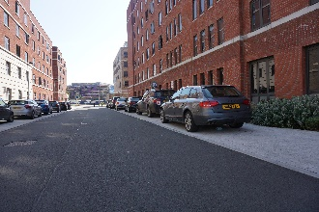
- Students Union. The pavements outside the students union are very wide but cars often park on them which obstruct the walkway. There is little to no space left for wheelchair users and they are then forced to use the road. As this is the bus route, this is very unsafe.

- Students Union. The door into the students union is very heavy and difficult for anyone to open, including people who are able-bodied.
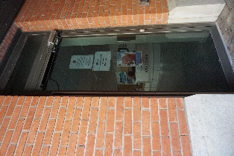

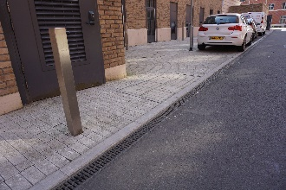
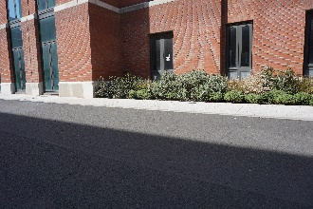
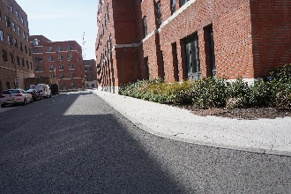
- Students Union. Around the corner from the students union these no proper crossing but there is one dropped kerb with tactile paving stones on one side of the road but not on the other.

- Residences. The lifts in the residences do not have braille on the buttons on either the interior or exterior of the lift.
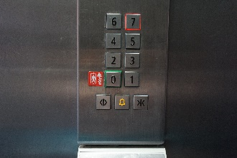
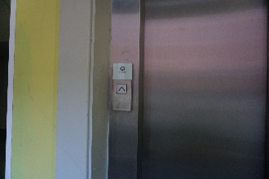

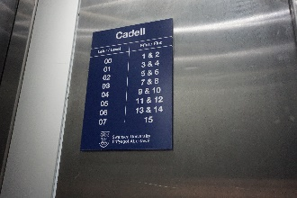
- Residences. The signs in the building showing where the different flats and rooms can be found are not in braille, this may make it difficult for visually impaired people to find their way around the building.

- Residences. The refuge area for disabled people does not show where an evac-chair can be found. This needs to be displayed so the evac-chair can be found and used quickly during emergencies.
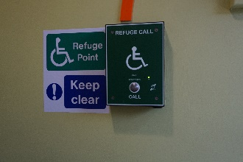

Conclusion

This report of the Swansea University Singleton Park Campus and Bay Campus has revealed many problems which make the university inaccessible. A total of 166 issues were identified with many of those have more than one case of the problem.

104 issues were found on Singleton Park Campus and 42 were found on Bay Campus. As mentioned in the introduction of this report, the report hopes to be as comprehensive as possible but it is possible that some issues were missed and therefore the total number of issues could be far higher.

It is the belief that based on the evidence collected, the university needs to make many changes before it could be seen as being fully inclusive. There are many problems which could be resolved easily and quickly. The problems identified need to be resolved as quickly as possible as they are creating inequalities within the university. They are making it more difficult for disabled students to attend university and this is compromising their ability to learn and receive a good quality education.

